Nature bag and Files
Nature bag unit is a Kudumbashree micro enterprise functioning in Pandalam was started in 2014.The unit is significant with eco-friendly products. They contributed to the success of the project Mission Green Sabarimala by the production of cloth bags. Paper bags, file folders, jute bags, cloth bags are their major products. Timeliness is the specialty of the unit.
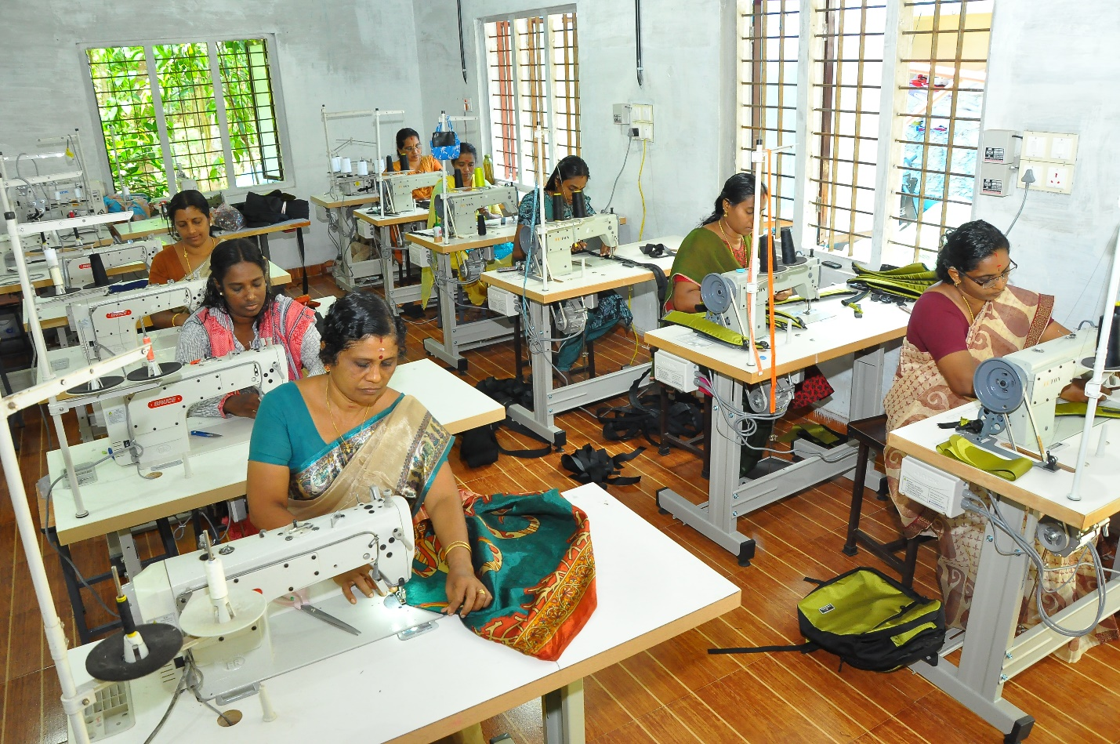
First they started their venture with paper bags and office files. Then they started laptop bags, jeans as well as jute bags, school bags etc. They got trained from Rural Self Employment Institute. Now they stitch cloth bags, hats etc. They market their products in shops at Pandalam as well as in the consumer fed units and thriveni shops.

